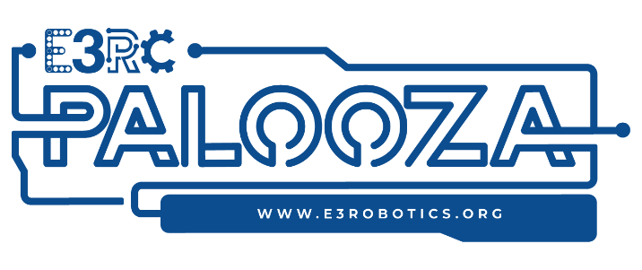
E3 Robotics Center
3709 Cassopolis St Suite E
Elkhart, Indiana 46514
www.E3robotics.org

Dear Community Member,

Will you help us create a perfect May weekend when families and friends come together to play and say a big thank you to essential workers and businesses. They have and continue to support our communities throughout this past year.

During the pandemic, the department of education and other grant funding normally available to not-for-profit organizations like E3 Robotics were redirected to support the remote educational needs driven by virtual learning, and rightfully so.

These circumstances gave birth to E3RC- Palooza! We are asking for your help to make it extra special as we, as a community, give a big hug to the ones who helped us through, including you.

We are looking for items to raffle and financial donations to help with this two-day event's costs. Please consider partnering with us by offering a raffle item or sponsoring one or several essential workers.

Please contact me directly with questions about pick-up instructions. Thank you in advance for your donation.

With Kind Regards,

Patsy Boehler
Development Director
E3 Robotics Center
pboehler@e3robotics.org

P.S. – Our goal is to have 200 items to raffle by mid-April. Thank you!!!!

