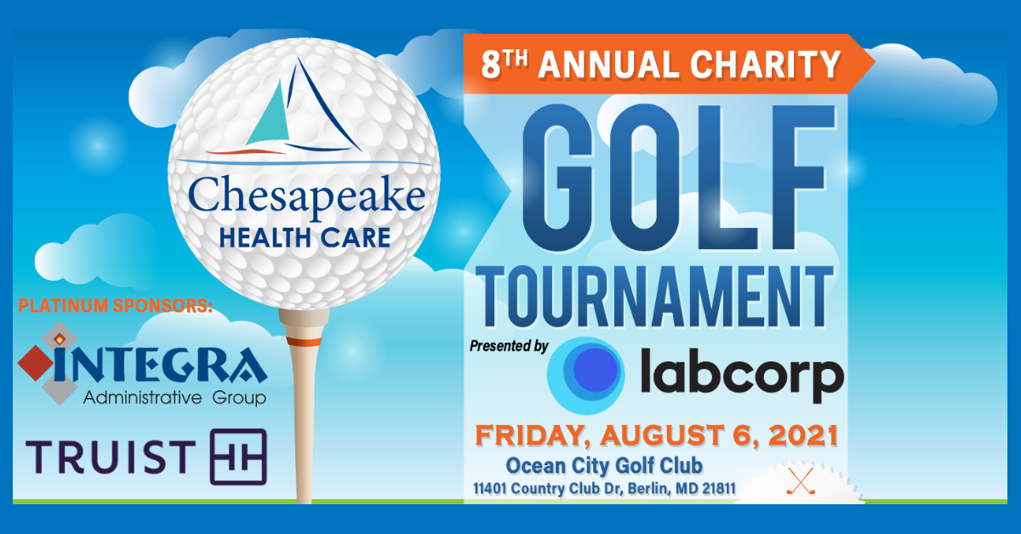
SPONSORSHIP OPPORTUNITIES

Exclusive! Title Sponsor – $10,000
Exclusive Sponsor of Tournament - Only 1 available!
As a Title Sponsor, your Company will receive the following exclusive benefits:
- Co. name & logo in the title of the tournament & all golf trophies.
- Co. name & logo on all advertising, printed & digital.
- Co. name & logo on tee sign & on golfer's carts.
- Presenter of golf trophies to winners.
- Greens and cart fees for 8 players (2 teams)
- Breakfast, lunch, on-course beverages

Platinum Sponsor – $5,000
Only 4 sponsorships available!
As a Platinum Sponsor, your Company will receive the following exclusive benefits:
- Company name and logo in all promotional material.
- Company name in all advertising, social media, and PR efforts.
- Company logo on tournament banner and tee sign
- Greens and cart fees for eight players (two foursomes)
- Breakfast, lunch, on-course beverages

Gold Sponsor - $2,500
As a Gold Sponsor, your Company will receive the following exclusive benefits:
- Company name and logo in all promotional material.
- Company name in all advertising and PR efforts.
- Company logo on tournament banner and tee sign on course.
- Greens and cart fees for four players (one team)
- Breakfast, lunch, on-course beverages

Silver Sponsor - $1,000.00
As a Silver Sponsor, your Company will receive the following benefits:
- Company logo on tournament banner and tee sign on course
- Complimentary breakfast, lunch, on-course beverages, embroidered golf shirts, and gift bags for four players.
- Opportunity to provide company information and/or products in golfer's gift bags.
- Greens and cart fees for four players (one team)
- Breakfast, lunch, on-course beverages

Exclusive! Golf Ball Sponsor - $2,500
As the Golf Ball Sponsor, your Company will receive the following exclusive benefits:
- Exclusive sponsor of a Sleeve of Titleist Golf Balls (3) imprinted with your company logo on each golf ball, given to each player.
- Company name and logo on tee sign, website & promotional material
- Complimentary breakfast, lunch, on-course beverages, embroidered polo shirts, and gift bags for four players
- Opportunity to provide company information and/or products in golfer's gift bags.
- Greens and cart fees for four players (one team)

Exclusive! Breakfast Sponsor - $1,000
Exclusive! Only 1 available
As the Exclusive sponsorship of golfer’s breakfast, your Company will receive:
- Company name and logo on a sandwich board sign in the breakfast area.
- Company name and logo on the tournament website, and tee sign on the course.

Exclusive! Lunch Sponsor - $2,000
As the Exclusive sponsorship of golfer's lunch, your Company will receive:
- Company name and logo on a sandwich board sign in the lunch area.
- Company name and logo on the website, and tee sign on the course.
- Opportunity to put logo imprinted items in golfer's gift bags.

Exclusive! Golf Shirt Sponsor - $3,500
Exclusive! Only 1 available
As the Exclusive sponsorship of the golf shirt, your Company will receive:
- Corporate logo embroidered on the sleeve of golf polo shirts given to each player.
- Golf Shirt Sponsorship signage at Clubhouse
- Company name and logo on website and all promotional material.

Beverage Cart Sponsor - $1,000
Only 4 Available!
As a Beverage Cart Sponsor, your company will receive the following benefits:
- Company Logo prominently placed on one side of the beverage cart.
- Company logo on tournament website.
- Opportunity to put company information and/or logo imprinted items in gift bag.

Putting Contest Sponsor - $1,000
Exclusive! Only 1 available
As the Exclusive sponsor of putting contest, your Company will receive.
- Company logo on a flag at the putting green.
- Company logo on signage on course.
- Company name and logo on the website.
- Prize provided by Chesapeake Health Care.

Pin Flag Sponsor - $300
Only 18 Available!
Pin Flag Sponsor benefits include:
- Company name or logo featured on the pin flag of 1 Hole.
- Company logo on tournament signage as a sponsor
- Opportunity to include branded promotional items in the welcome bag for each golfer.
- Company logo on the tournament website with a live link to your company website
- “Thank you” acknowledgment thru social media.
And...
- You get to keep your flag as a souvenir!

Tee Sign on Golf Course - $150
- Company name and logo on tee sign on course.

