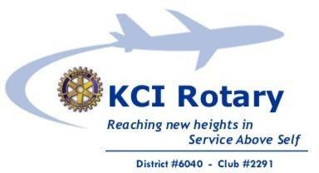

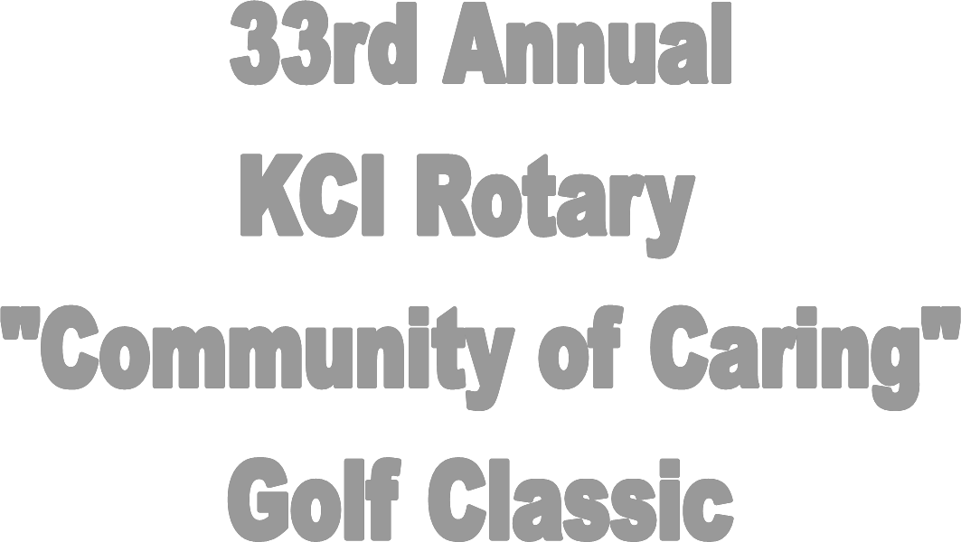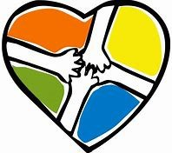

WHEN: Monday, June 3, 2019

7:00 AM Registration / Breakfast

9:00 AM Shotgun Start

WHERE: The Deuce at the National Golf Club

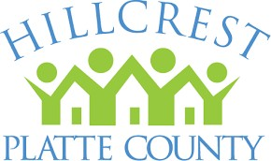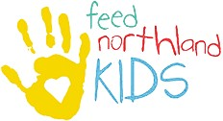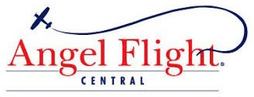6415 N. National Dr. Parkville, MO 64152

**Tax-Deductible contributions help fund:**

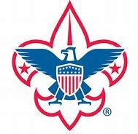**S $1,000**

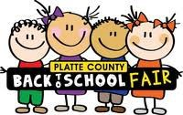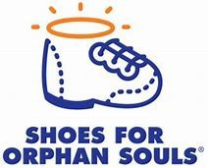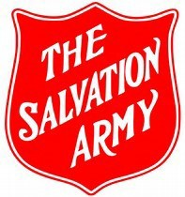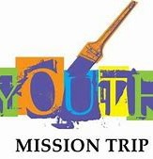

Includes: *Entry into drawing with chance to win $2,000*

**p**

Prominent Signage

Tournament Promotion Recognition 4 Golfers & 4 Game Packs

**o**

# n



**$500**

Includes: Hole signage

2 Golfers & 2 Game Packs

**s o r s h i**



**$250**

Includes: 1 hole sign

1 Golfer & 1 Game Pack

$100

**p** Includes: 1 hole sign

# s

***SPONSORSHIP & REGISTRATION***

[**WWW.KCIROTARYCLUB.COM**](http://WWW.KCIROTARYCLUB.COM/)  **@KCIROTARY **

**@KCI_ROTARY **

**KCI ROTARY CLUB #2291 ** [**KCIROTARY@GMAIL.COM**](mailto:KCIROTARY@GMAIL.COM)