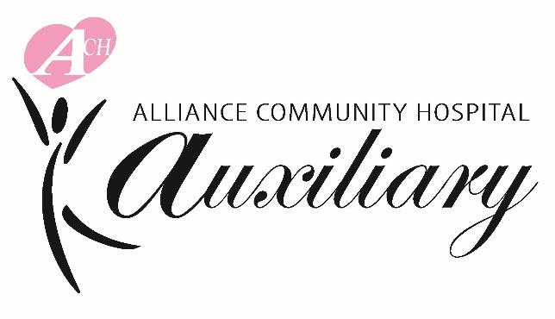
Alliance Community Hospital Auxiliary
Golf Outing
Friday, September 26, 2025
8:00 a.m. – 8:45 a.m. – Breakfast & Registration
9:00 a.m. – Shotgun Start
Pleasant View Golf Club
14605 Louisville St. N.E., Paris, OH 44669

Sponsorship Opportunities:
- $2,500 Gold Title Sponsor Includes foursome, hole sponsor, opportunity to provide marketing
materials, logo on signage, and the opportunity to speak at lunch.
- $1,500 Silver Team Sponsor Includes foursome, hole sponsor, logo on signage, and opportunity
to provide marketing materials.
- $1,000 Bronze Team Sponsor Includes foursome, hole sponsor, and logo on signage
- $ 500 Munchy Mobile Sponsor Provides soft drinks and snacks to players. Includes hole sponsor,
(Two Available) logo on Munchie Counter, and logo on signage.
- $ 100 Hole Sponsor Name and logo displayed on the course.

Golf Registration:
- $400 Foursome Registration Includes 18 holes of golf, cart, and dinner
- $100 Individual Registration Includes 18 holes of golf, cart, and dinner (We will pair you with a team)

Please send logo for signage to connie.jones@aultman.com.

Donation: I’d like to make a donation of $_________________ to Alliance Community Hospital Auxiliary.

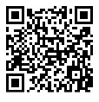
Payment Methods:
- Enclosed is a check payable to Alliance Community Hospital Auxiliary
- Pay or Register Online by scanning the QR Code or visit:
https://app.eventcaddy.com/events/alliance-community-hospital-auxiliary-golf-outing

NOTE: Information must be completed below:
Company Name (for sponsor listing):
Team Name (for program listing):
Captain Name:
Address:
Email:
Phone: _______________________________
Player 2 Name: _________________________ Email:______________________ Phone:________________
Player 3 Name: _________________________ Email:______________________ Phone:________________
Player 4 Name: _________________________ Email:______________________ Phone:________________
If players are not finalized yet, please email Connie.Jones@aultman.com once confirmed.

