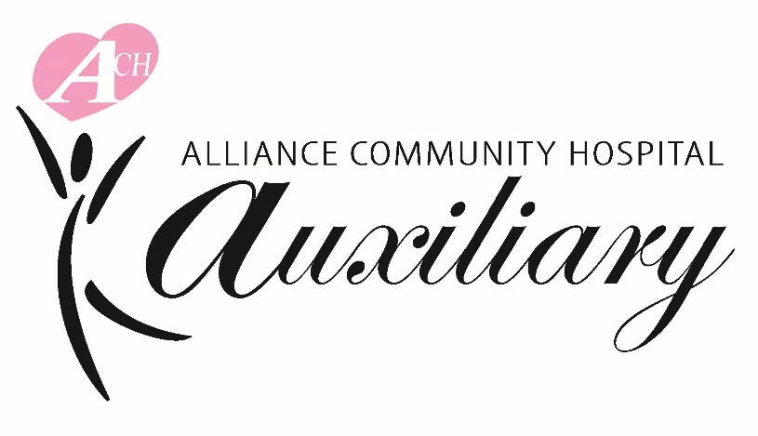

Dear Friend:

The Alliance Community Hospital Auxiliary is proud to announce their Inaugural Golf Outing that will be held, rain or shine, at 9:00 a.m. on Friday, September 26, 2025, at Pleasant View Golf Club. The event is a four-person scramble, which includes 18-holes of golf, cart, breakfast, lunch, dinner, and giveaways. The cost is $400 per four-person team or $100 for individuals. Registration and a continental breakfast will be from 8:00 a.m. – 8:45 a.m. with a shotgun start at 9:00 a.m.

If you are unable to join us, please consider being a sponsor, making a donation, or sponsoring a hole. Your support of this event will help the Auxiliary continue their mission to promote, advance, and improve the welfare of Aultman Alliance Community Hospital with the best interests of the community. Proceeds from this year’s outing will be used to purchase new equipment for the Hospital.

To register online and review sponsorship and donation opportunities online, go to: https://app.eventcaddy.com/events/alliance-community-hospital-auxiliary-golf-outing or scan the QR Code at the bottom this letter.

Please respond soon, as the field is only open to 36 teams and slots are already being booked. It will be great fun for a great cause!

We look forward to hearing from you soon! If you have any questions, please call me in the Hospital’s Administration office at (330) 596-7014 or connie.jones@aultman.com.


Sincerely,


Connie L. Jones
Event Chairperson

