

We Serve

Fuquay Varina Lions Club

Annual Golf Tournament
Monday, April 28, 2025
9:00 A.M. Shotgun Start
Bentwinds Golf & Country Club
6526 Dornoch Place
Fuquay-Varina, NC

Evelyn Walters
PGA PROFESSIONAL
6536 Dornoch Place

Fuquay Varina, NC 27526 www.bentwinds.org

Office: 919.552.5656 ext. 111
Mobile: 919.796.0312
Email:evelynwalters@bentwinds.org

2025 – List of Contributors

Adorn Home Furnishing
Apex Skin Center
Ashworth
Assured Audiology & Hearing Solutions
Betts Tackle
Big Monkey Renovation & Repair
Bojangles
Bryan-Lee Funeral Home, Inc,
Carolina Family Foot Care
Cellar55
Chicora Golf Course
Chiropractic Partners Brook Wallace
Cleveland Draft House
COSTCO
Curry Engineering Group
Ed’s Family Restaurant
Edward Jones – Mary Elizabeth Twiddy
Family Optical
Far Packaging Company
Fat Cat Homemade Ice Cream
Freight Handlers. Inc (FHI)
First National Bank
Food Lion
Fuquay Eye Care
Fuquay Tire & Automotive Center
Fuquay Veterinary Hospital
Harris Teeter
Hiester Automotive Group
Hiester Chevrolet
Knights Play Golf Center
Holly Springs Eye
K. B. Johnson Oil & Gas
Leap Frog Landcare
Lochmere Golf Course
Main St. Plumbing
Massengill Design & Build
Mike Hamby and Assoc.
Mullen Engineering
My Eyes Optometry
NC Textiles Foundation
Nils Mediterranean Cuisine
Pittman Family Orthodontics
Respicare DME, Inc
Rock Solid Warrior
Senter, Stephenson & Johnson
Sheetz
Terry Bass, CFP
The Mason Jar Tavern & Mason Jar Lager Co.
Thomas Funeral Home, Inc
Trinity Episcopal Church
WakeMed Health & Hospital’s
Wholesale Motors & Rick Hancock Pre-Owned
Zaxby’s
Zeera Indian Restaurant, LLC


Let’s Play Golf!

Play is governed by the USGA Rules of Golf and the following Local Rules:
OUT OF BOUNDS: Where white stakes are used. The green and fairway on hole 17 is out of bounds when playing hole 13 and the green and fairway on hole 16 is out of bounds for those playing hole 14. A ball coming to rest on or crossing any public road is considered out of bounds. This rule applies to holes 1, 12, and 13.

WATER HAZARDS: Defined by yellow lines and designated yellow stakes. When both lines and stakes are present, the stakes identify the hazard, and the lines define the margin.

LATERAL WATER HAZARDS: Defined by red lines and designated red stakes. When both lines and stakes are present, the stakes identify the hazard, and the lines define the ++margin.
Slope Rating Course Rating
Black 72.8 137
Blue 71.0 126
White 69.4 117 (Men)
74.6 137 (Women)
Red 70.4 121
All sprinkler heads are measured to the center of the greens.



R. Terry Bass, CFP

Financial, Estate, and Philanthropic Planning

155 Jackson Road 919/552-1706
Fuquay-Varina, NC 27526 800/803-9647
tbass@capital-invest.com Cell: 919/801-4013 Fax: 919/552-0238
Securities offered by Capital Investment Brokerage, Inc.17 Glenwood Ave., Raleigh NC 27622 (919).831-2370 +Member FINRA & SIPC
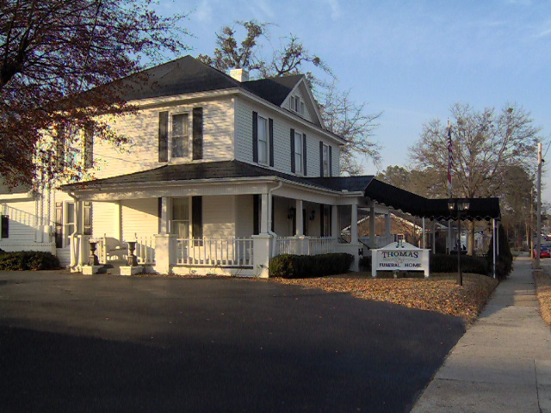

Thomas Funeral Home
“A Family Serving Families”
Phone: (919) 552-4171
Fax: (919) 567-0049

Address: 401 N. Ennis Street
Fuquay-Varina, NC 27526

Hole 1
Par: 5
Men's Handicap (Black/Blue/White): 9
Gold Handicap: 3
Red Handicap: 7

Hole Description:
The journey begins on a beautiful par 5. Aim your tee shot to the right of the bunkers on the left and safely lay up to guarantee a par. Go for the green in two and be careful of going long or left.

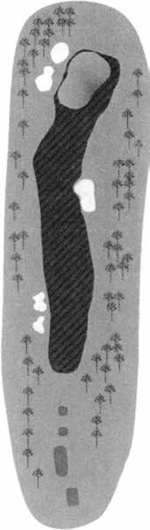
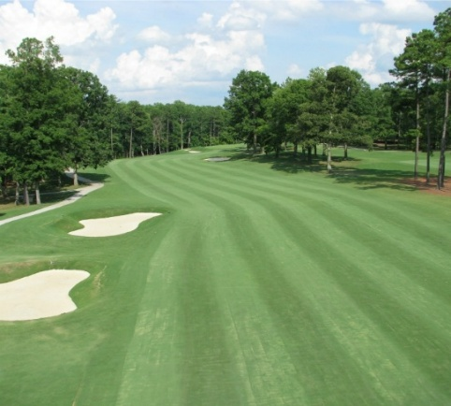

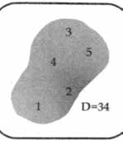
Black 554
Blue 544
White 501
Red 414







Fuquay-Varina Location
6109 NC-55, Suite 125,
Fuquay-Varina, NC 27526
Phone: (919) 307-7448
Email:
jennifer.womble@rocksolidwarrior.com

Hole 2
Par: 4
Men's Handicap (Black/Blue/White): 17
Gold Handicap: 17
Red Handicap: 15

Hole Description:
Standing on the tee your first thought may be Go for it”, but a slight miss and you could be swimming. Play smart from the tee and you are sure to make birdie on the hole.
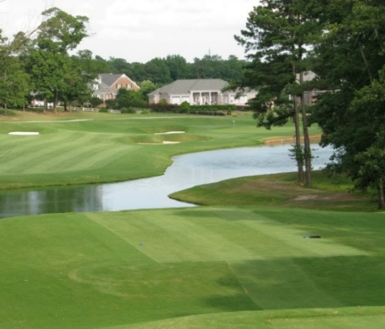
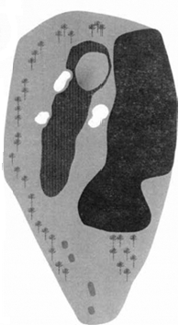
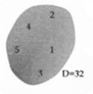
Black 554
Blue 340
White 330
Red 267

Hole 3
Par: 3
Men's Handicap (Black/Blue/White): 11
Gold Handicap: 9
Red Handicap: 17

Hole Description:

Be sure to check the breeze on this hole, a subtle shift in wind can leave you short or long. A two-tier green be precise with your shot or this could be a three-putt hole.


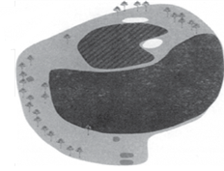

Black 173
Blue 169
White 156
Red 102

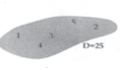

Hole 4
Par: 4
Men's Handicap (Black/Blue/White): 15
Gold Handicap: 11
Red Handicap: 9

Hole Description:
From the tee hit a straight shot down the
Fairway but be precise with your approach.
Come up short and you may find yourself
in steep faced with a greenside bunker.
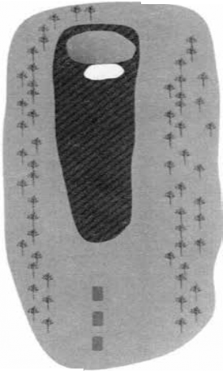
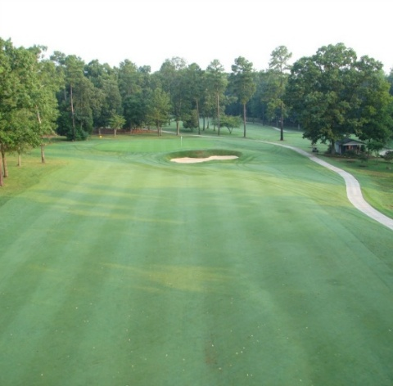

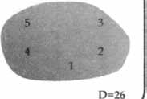
Black 354
Blue 329
White 319
Red 182

Hole 5
Par: 5
Men's Handicap (Black/Blue/White): 13
Gold Handicap: 15
Red Handicap: 11

Hole Description:
A straight, uphill par 5 this hole for the long hitters is an eagle opportunity. If you are
laying up, be precise and be warned. The
further the second shot goes, the tighter the fairway is protected with deep faced fairway bunkers on the right.
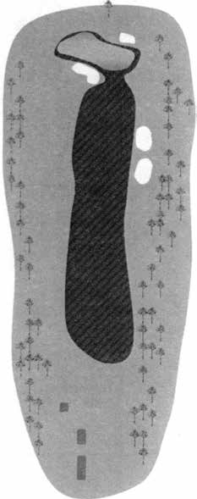
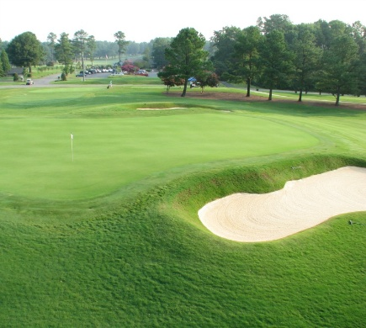

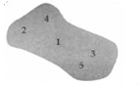
BLACK 500
BLUE 489
WHITE 471
RED 339

Hole 6
Par: 4
Men's Handicap (Black/Blue/White): 1
Gold Handicap: 1
Red Handicap: 1

Hole Description:
Deservingly the number 1 handicap hole
This uphill par 4 is an outstanding test. An excellent drive is required and an even
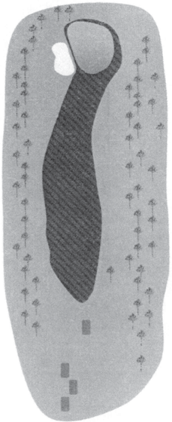
better second shot, be prepared to get up and down for par.
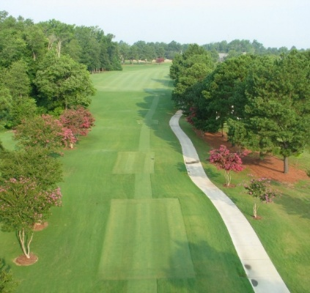

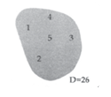
BLACK 470
BLUE 431
WHITE 406
RED 292

Hole 7
Par: 4
Men's Handicap (Black/Blue/White): 7
Gold Handicap: 7
Red Handicap: 5

Hole Description:
A severe dogleg to the right, the smart play
there is laying up. Be sure to hit it the right distance, short could leave you with a tricky
shot, long could leave you with an even trickier shot and right could leave you in a cluster of bunkers. This green is large with a severe
swell on the right side.
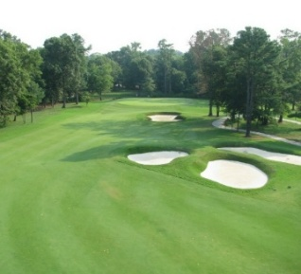
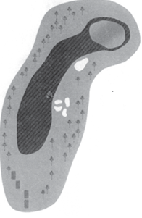

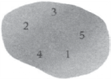
BLACK 367
BLUE 344
WHITE 321
RED 298


The Hole-in-one prize is $25,000 towards the purchase of any New Chevrolet at the John Hiester Chevrolet Fuquay Varina.

Hole 8
Par: 3
Men's Handicap (Black/Blue/White): 5
Gold Handicap: 13
Red Handicap:13

Hole Description:
You must be accurate on this par 3 as it is being guarded by sand traps.

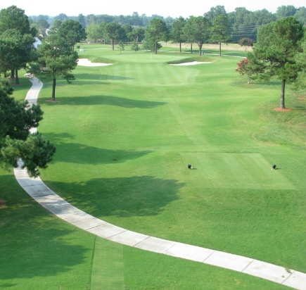
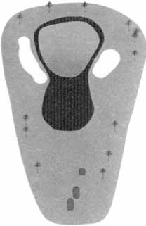

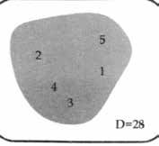
BLACK 191
BLUE 180
WHITE 173
RED 136





9205 S Fuquay Ave,

Fuquay-Varina, NC 27526

919.552.0849

205
Hole 9
Par: 4
Men's Handicap (Black/Blue/White): 3
Gold Handicap: 5
Red Handicap: 3

Hole Description:
A fairway bunker guarding the right side and another lurking down the left requires an accurate shot from the tee. Pick the right
club with your second shot and avoid the left green side bunker.
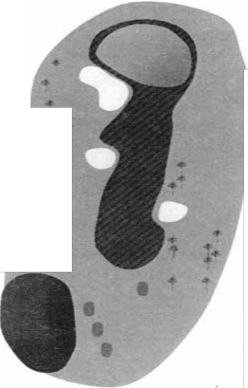
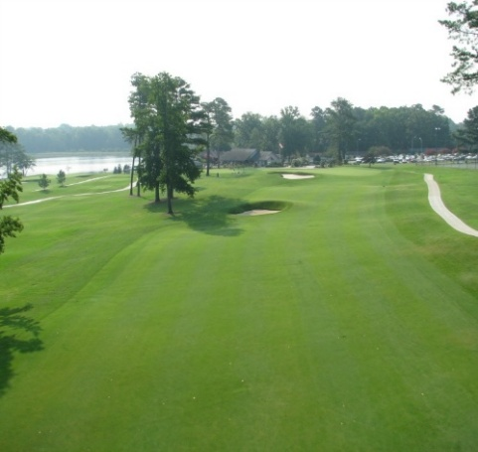

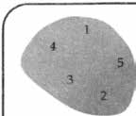
BLACK 425
BLUE 398
WHITE 374
RED 297




Lunch compliments of









Phone: (919) 762-6845
Web Address: www.apexskincenter.com
Email: info@apexskincenter.com
Address: 1006 Procure St. Suite 100
Fuquay-Varina, NC 27526



ADDRESS:
1701 W. Academy St., PHONE: 919-552-2226
PO Box 57, FAX: 919-552-3423
Fuquay-Varina, NC 27526 EMAIL: bettstackle@bettstackle.net


Family Owned & Operated Over 35 Years

Call us: 1-919-552-9090

108 E Academy St.

Fuquay-Varina, NC 27526

Mullen Engineering

703 N. Main St.
Fuquay-Varina, NC 27526

mullenengineering.net



2905 Air Park Rd.
Fuquay-Varina, NC 27526
Phone: 919.552.2422


Phone: (919) 427-3131
Email: service@leapfroglandcare.com
Mailing address: P.O. Box 5367,
Cary, NC 27512


Rector: Father Bob Henderson
1128 South Main Street,
Fuquay-Varina, NC 27526
Phone: 919.552.1056
Email: info@trinityfuquay.org



Hole 10
Par: 5
Men's Handicap (Black/Blue/White): 14
Gold Handicap: 14
Red Handicap: 6
BLACK 480
BLUE 475
WHITE 457
RED 390

Hole Description:
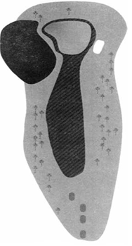
Making the turn this short par 5 is a chance to start the back 9 under par. Go for it with your second shot successfully and you are sure to get a birdie but beware of the well-guarded green with water on the left and a deep aced bunker on the right.
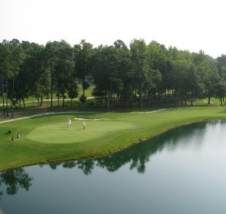
, NC 27526
Phone: 919.552.2422

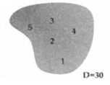

Hole 11
Par: 3
Men's Handicap (Black/Blue/White): 16
Gold Handicap: 18
Red Handicap: 16

Hole Description:

The shortest par 3 on the course, go for the middle of the green and par is a guarantee.

Do not go long, out bounds are lurking close

by.43

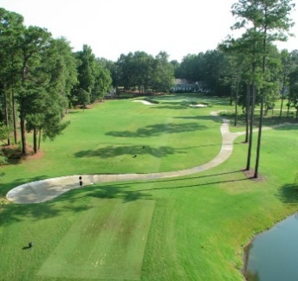
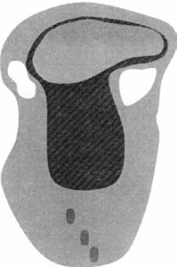
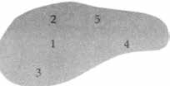
BLACK 165
BLUE 148
WHITE 139
RED 112

Hole 12
Par: 4
Men's Handicap (Black/Blue/White): 2
Gold Handicap: 2
Red Handicap: 14
BLACK 411
BLUE 383
WHITE 353
RED 265

Hole Description:
A sharp dogleg left accuracy is necessary from the tee. A well-placed tee shot will leave you with a simple second shot. A large green placement is important, otherwise a three putting could occur.
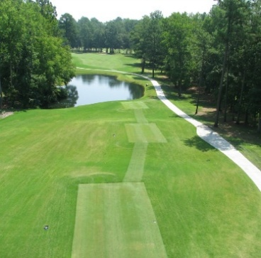

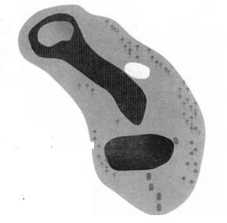
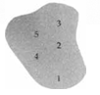

Hole 13
Par: 4
Men's Handicap (Black/Blue/White): 8
Gold Handicap: 4
Red Handicap: 12

Hole Description:
A dog-leg-right, standing from the tee you
have an option. Play safe or go for it! Cutting around the corner will leave you with a short shot but cutting it too short could leave you
the hazard guarding the right side.
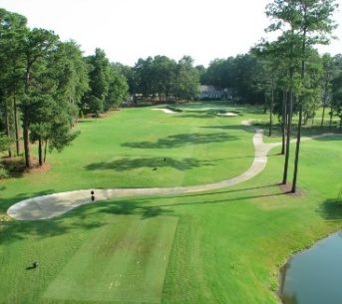
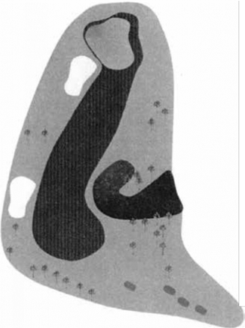
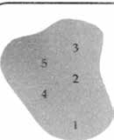
BLACK 403
BLUE 389
WHITE 362
RED 283

Hole 14
Par: 5
Men's Handicap (Black/Blue/White): 12
Gold Handicap: 12
Red Handicap:10

Hole Description:
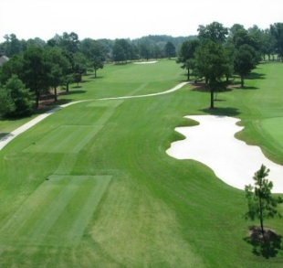
A double dogleg, this hole can be a great start to the final holes of a round. Play safe and you can get an easy par, go for it and you can easily find trouble.
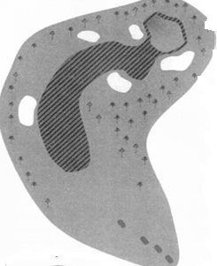
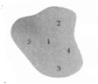
BLACK 512
BLUE 478
WHITE 454
RED 417

Hole 15
Par: 3
Men's Handicap (Black/Blue/White): 18
Gold Handicap: 16
Red Handicap: 18

Hole Description:
One the largest greens on the course, ball placement is a must.
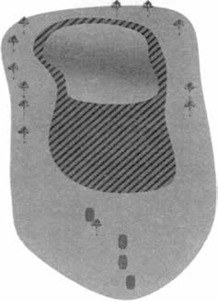

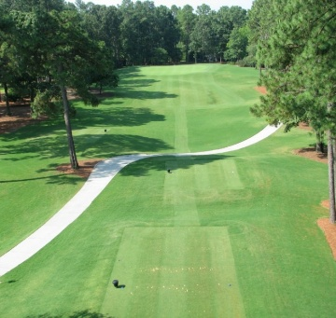

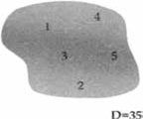
FAR PACKAGING

2905
BLACK 181
BLUE 159
WHITE 151
RED 109

Hole 16
Par: 4
Men's Handicap (Black/Blue/White): 6
Gold Handicap: 10
Red Handicap: 4

Hole Description:
A dogleg left, beware of cutting it too close
to the corner. Out of bounds and deep
swells protect the left side for those trying
to make this challenging par 4 an easier feat.
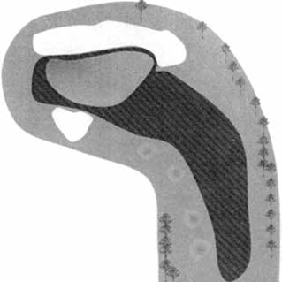
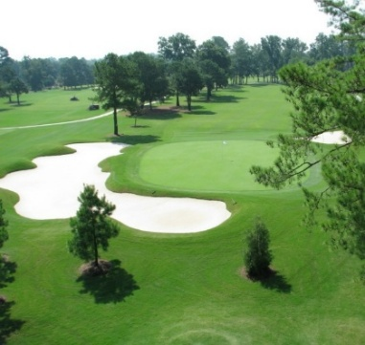
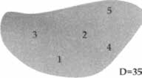
BLACK 432
BLUE 240
WHITE 372
RED 295

Hole 17
Par: 4
Men's Handicap (Black/Blue/White): 10
Gold Handicap: 6
Red Handicap: 8

Hole Description:
A short shot of the tee keeps your driver in
the bag. It could go long, and you could be in
the water.

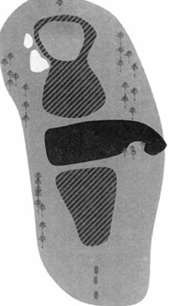
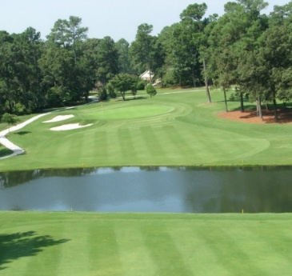

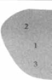
BLACK 372
BLUE 365
WHITE 340
RED 305

Hole 18
Par: 4
Men's Handicap (Black/Blue/White): 4
Gold Handicap: 8
Red Handicap: 8

Hole Description:
Ball placement from the tee is very important to ensure par on this visually intimidating hole.
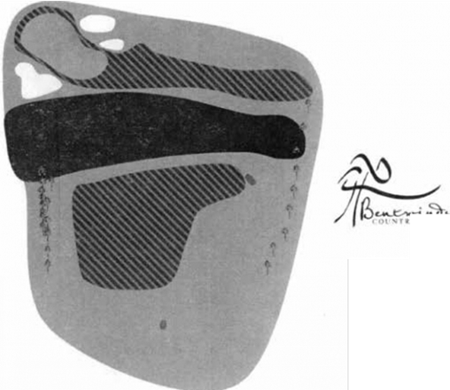
BLACK 405
BLUE 380
WHITE 355
RED 242

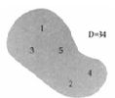

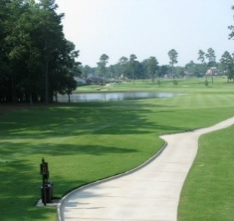









Physical Address: Mailing Address:
114 Raleigh Street PO Box 446
Fuquay-Varina, NC 27526 Fuquay-Varina, NC 27526
Tel: 919.552.4707 Fax: 919.552.1032



1420 East Broad St, Fuquay-Varina, NC 27526
919-659-5500

Water complements of






Bryan-Lee Funeral Homes -

Raleigh – Phone: 919-832-8225

Garner – Phone: 919-772-8225

Angier - Phone: 919-639-8225



Water Compliments of







Eyecare for the whole family.
608 Holly Springs Rd.
Holly Springs, NC27540
(919) 577-3937
appointments@hollyspringseye.com





Hamby Family Dental Center
7628 Purfoy Road
Fuquay-Varina, NC 27526
Phone: 919-552-2431


984-268-3679




Fuquay Varina Office
955 East Broad St.
Fuquay Varina, NC 27526
Phone: (919) 557-5148 Fax: (919) 557-5645





Flowers on Board Street

Phone: 919.557.3410

Store Hours: 9am – 5pm

Mon. through Sat.

Closed Sunday



Where Cooking Is an Art and Eating Is a Pleasure

Our Mission:

We are proud to serve you a delicious southern home cooked meal.

Our farm-to-table approach provides the freshest,

highest quality ingredients and flavor are available.

We honor the quality you expect and the service you deserve.

Thank you for choosing us for your dining experience for your family

Take-Out – Eat-In – Catering Event

Hours: Monday – Thursday 5:00 AM - 3:00 PM

Friday & Saturday 5:00 am -10 pm

Sunday Closed

43 East Depot Street

Angier, NC 27501

(919)-275-9454





Contact Us Today!

Main Phone: 919-617-0496
Fax Line: (828) 686-0359



www.fhiworks.com

Freight Handlers Inc aka FHI
310 N Judd Pkwy NE, Fuquay-Varina, NC 27526
(919) 552-3157



505 N Judd Pkwy NE Ste 109
Fuquay Varina. NC 27526

Phone: 919-557-0308











Address:

Wholesale Motors
1211 North Main Street
Fuquay Varina, NC 27526
919-552-6445111 N. Main St.
Fuquay-Varina, NC 27526
Phone: 919-762-7176



Rick Hancock
Preowned, LLC

1229 N Main St.
Fuquay-Varina, NC 27526

919-557-1100

Place on the back page inside cover.


North Carolina Textile Foundation
The North Carolina Textile Foundation makes the groundbreaking, industry-leading work of the Wilson College of Textiles possible.

Back Cover




