
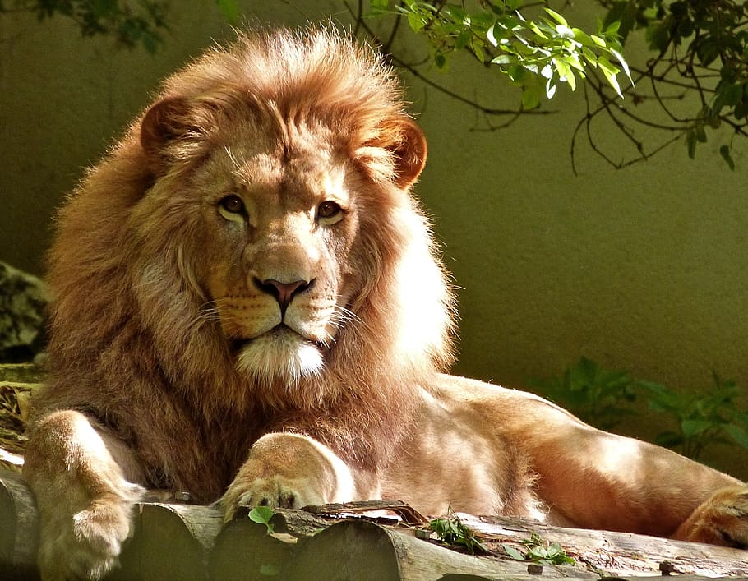
Would you like to join the Fuquay Varina Lions Club?

Fuquay Varina Lion Club
P.O. Box 117
Fuquay-Varina NC 27526
Fuquay-Varina, a community that thrives on volunteerism and civic engagement,
takes immense pride in its rich history of service-oriented organizations.
Among these, the Lion’s Club stands out as a beacon of compassion and
commitment, tireless championship, causes that uplift individuals and families alike.
Eighty-three years of service to the
Fuquay-Varina Community
Are you interested in:
Annual Charity Golf Tournament
Developing Social Media Content
Certified in KidSight
Recycle Glasses
Development of program to pay for Eye Exams/Glasses
Scholarships
Recruitment
Speaker Series
Leadership

Our Foundation supports the programs and services
for the blind and visually impaired below:

- Brighter Visions Peace Poster
- Clinical Eye Research Boys & Girls Home
- Radio Reading Service LEO's Youth Exchange
- Fishing Tournament (VIP) visually Eye Exams
- Impaired Persons Childhood Cancer
- Governor Morehead School Scholarships
- Hearing and Sight Conservation Leader/Guide Dog
- Technology for the Blind/E Sight
- For additional information contact
- fvlions.president@gmail.com

