***KidSight Program***

KidSight program is a free eye screening (not an eye exam) offered by the Lions Club for children between the ages 6-months to 7-years of age.

80% of a child’s learning is through their vision. The #1 cause of preventable vision loss in the USA is amblyopia. Parent(s) receive a Pass or Referral. The vision screening may detect it, as well as the following:

**Myopia** - nearsightedness

**Astigmatism** – corneal irregularities

**Amblyopia** – “lazy eye”

**Anisometropia** – unequal refraction of both eyes

**Anisocoria** – unequal pupil size

**Misalignment** – eye turning in or out

**Hyperopia** - farsightedness

***Funds are used to pay for the equipment.***

*T*he purchase of the cameras is expensive, especially considering how hard it is for clubs to raise money to provide community services. The camera’s initial cost is between $5,000 and $8,000.

Second, ongoing operational costs include replacement batteries, printer and paper, ink, extending warranty coverage, and non-warranty repairs. The life of a camera is about 10 years.

***Scholarships***

Two scholarships are awarded annually to eligible high school seniors in Fuquay-Varina & Willow Spring. The awards are in the amount of $1,500 each. Our goal is to raise enough funds to increase the scholarship amount.

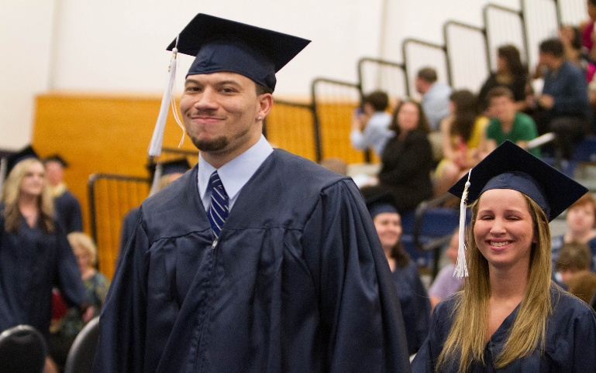

**

***Camp Dogwood is one component of Brighter Visions***

Nestled within our philanthropic endeavors is Camp Dogwood, a recreational retreat center that stands as a therapeutic oasis for individuals with visual challenges. This facility is the flagship of the North Carolina Lions Club Foundation. It is an inclusive program designed for adult residents of North Carolina who are blind or visually impaired.  Our commitment to serving the blind and visually impaired extends beyond traditional assistance.

*

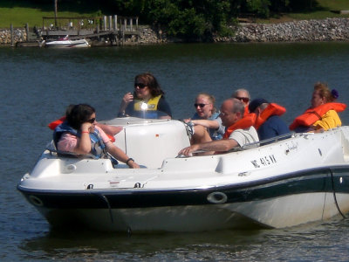

It offers the blind and visually impaired persons

an environment that is uniquely designed for them.

Located on the shores of Lake Norman,

some of my favorite activities are boating,

swimming, fishing, skiing, and tubbing.

