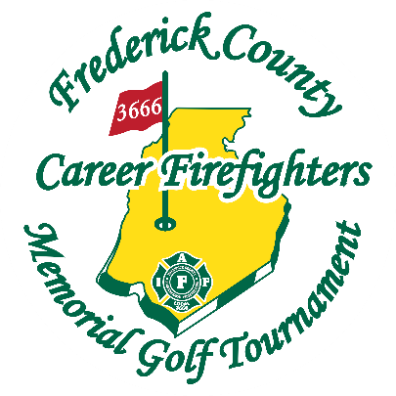**Frederick County Career Firefighters Memorial Golf Tournament**

**Sponsorship Levels**

* **Platinum Sponsor $3,500 (1 Available)**

Complimentary foursome in the tournament. Corporate logo on magnetized ball marker affixed to golf glove given to each player. Exclusive corporate logo on customized scorecards for the tournament given to each team. Corporate logo on all golf tournament signage. 2 tee box signs. Corporate logo on Sponsorship page on the tournament website. Announcement before and after the tournament as the Event Sponsor for the tournament.

* **Gold Sponsor $2,500 (3 available)**

Complementary foursome. Corporate logo printed golf balls given to golfers. Corporate logo on tournament entry sign. 2 tee box signs. Corporate Logo on Sponsorship page on the tournament website. Announcement as a gold sponsor before and after tournament play.

* **Silver Sponsor $1,500 (10 available)**

Complementary foursome. Corporate logo affixed in the area of entry to the tournament and three 2.5' X 6' signs placed throughout the course. 2 tee box signs. Corporate logo on Sponsorship page on the tournament website. Announcement as a Silver Sponsor before and after tournament play.

* **Bronze Sponsor $1,000 (10 available)**

Complementary foursome. Corporate logo affixed in the area of entry to the tournament. 2 tee box signs. Corporate logo on Sponsorship page on the tournament website. Announcement as a Bronze Sponsor before and after tournament play.



* **Lunch Sponsor $1,500 (1 available)**

Corporate logo signage by the BBQ pit during the food preparation. Corporate logo on each table for all the players to see. Complementary foursome.

* **Hole in 1 contest $1,000 (1 available)**

Sponsor this year's $20,000 hole in one! Your corporate logo will be all over this hole, and on the website hole in one contest flyer! Your sponsorship will be announced before and after tournament play, as well as at the hole in one contest hole.

* **Beverage Cart $300 (4 available)**

Sponsor a Beverage Cart Today! Your beverage cart sponsorship gets your company logo placed on the side or front of the beverage cart for all players to see during tournament play!

* **Mens Longest Drive $250 (1 Available)**

Your company logo will be placed via 2 signs at the men’s longest drive hole.

* **Womens Longest Drive $250 (1 Available)**

Your company logo will be placed via 2 signs at the women’s longest drive hole.

* **Tee Box Sponsor $150**

With this sponsorship, your company logo will be placed at the tee box of a hole on the course. Requests can be made for specific hole numbers, however, not all requests will be able to be honored.